 US Department of Housing and Urban Development
Office of Policy Development and Research

Insulating Concrete Forms:
Installed Cost and Acoustic Performance

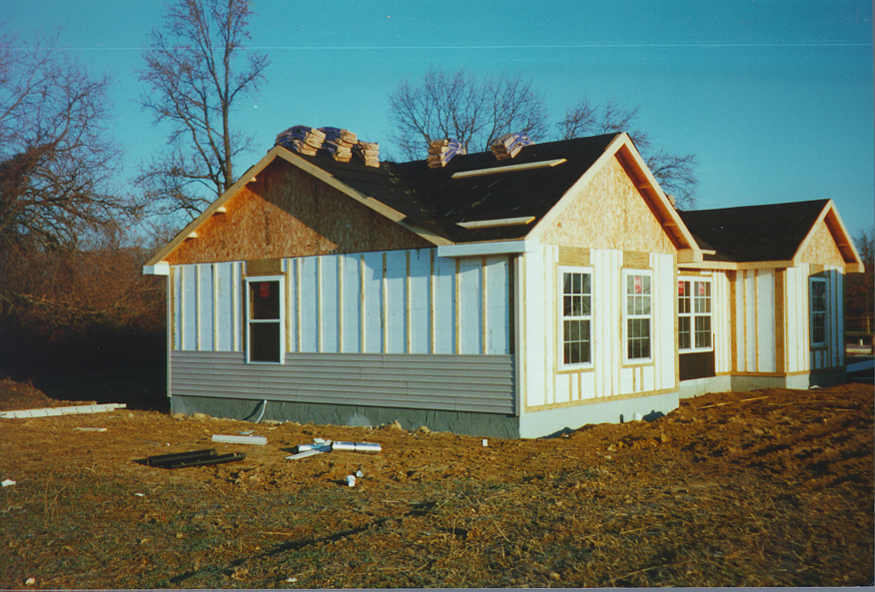

dfgjk
Insulating Concrete Forms:
Installed Cost and Acoustic
Performance

Prepared for:

US Department of Housing and Urban Development,
Portland Cement Association,
and
National Association of Home Builders

Prepared by:

NAHB Research Center, Inc.
Upper Marlboro, MD

December 1998

dfgjk

Foreword

As we near the end of the 1990s, we have reason to celebrate some of our successes in identifying and improving innovative materials that can help reduce our dependence on lumber and improve the building industry’s efforts to deliver affordable housing to our citizens. Throughout much of the decade, the U.S. Department of Housing and Urban Development has supported joint efforts with the Nation’s builders and manufacturers to accelerate the adoption of innovative materials for home construction. This includes efforts to improve the efficiency of lumber construction as well as researching alternatives such as cold-formed steel, panel construction, and insulating concrete form systems.

Despite these initial successes, we realize that our work is just beginning. The President’s new initiative, The Partnership for Advancing Technology in Housing (PATH), will build more durable and resource-efficient homes. We look forward to that challenge and continue to work closely with industry to achieve our goals.

Insulating concrete forms (ICFS) are an example of one of the technologies that the PATH program can capitalize on to improve our housing. This report contains results of one of our latest studies on this intriguing technology innovation. This report will allow builders to better evaluate the cost impacts of ICFs. It also identifies many opportunities to optimize the construction of homes using this technology. We hope you not only find this report valuable, but that you help us continue to improve these types of technologies by passing your experience and suggestions for improvements on to the many excellent manufacturers of these products.

Xavier de Souza Briggs
Deputy Assistant Secretary for Research,
Evaluation, and Monitoring

dfgjk
Acknowledgments

The NAHB Research Center Inc., located in Prince George's County, MD, was established in 1964 as a separately incorporated, wholly-owned, not-for-profit subsidiary of the National Association of Home Builders (NAHB), whose 197,000 members are involved in the construction of over 80% of U.S. homes. The Research Center studies all aspects of home building, tests and certifies building products in a fully equipped laboratory, and conducts a wide range of dissemination and training activities for builders, remodelors, and other participants in the housing industry. Our research is sponsored by NAHB, public agencies, and private-sector clients.

This report was prepared by the NAHB Research Center for the Portland Cement Association, National Association of Home Builders and the U.S. Department of Housing and Urban Development. Product donations were provided by Reddi-Form, Lite-Form, and Owens Corning. The homes studied in this work were constructed by Romak & Associates of Chestertown, Maryland. Sound transmission tests were completed by Hessler Associates, Inc. of Cabin John, Maryland.

Notice

The U.S. Government does not endorse products or manufacturers. Trade or manufacturers’ names appear herein solely because they are considered essential to the object of this report. The contents of this report are the views of the contractor and do not necessarily reflect the views or policies of the U.S. Department of Housing and Urban Development or the U.S. Government.
dfgjk

TABLE OF CONTENTS

TABLES AND FIGURES iv
EXECUTIVE SUMMARY v
INTRODUCTION AND SCOPE 1
Insulated Concrete Forms 1
DESCRIPTION OF HOMES 3
APPROACH 5
Installed Time 5
Labor Costs 5
Materials 6
Sound Tests 6
Energy and Thermal Tests 6
FINDINGS: LABOR AND COSTS 6
Labor Hours and Costs 7
Material Costs 7
Total Labor and Material Costs 8
Labor and Cost Observations 9
FINDINGS: SOUND TESTS 10
ENERGY AND THERMAL PERFORMANCE 12
CONCLUSIONS AND RECOMMENDATIONS 12
APPENDIX A - DETAILED LABOR DATA
APPENDIX B - DETAILED MATERIAL COST DATA
APPENDIX C – Excerpt from SOUND CONTRACTORS REPORT

TABLES AND FIGURES

TABLES

Table A - Total Productive Labor Hours by House Type and Component 7
Table B - Labor cost by House Type and Component 7
Table C - Material Costs by House Type and Component 8
Table D - Total Labor and Material Cost by House Type and Component 8
Table E - FSTC Ratings 10

FIGURES
Figure 1 – ICF Wall System Types 2
Figure 2 - Floor Plan of Test Homes 3
Figure 3 - Reddi-Form System 3
Figure 4 - Lite-Form System 3
Figure 5 - CMU Foundation Wall 3
Figure 6 - Location Map 4
Figure 7 - Site Plat 4
Figure 8 - View of Completed Homes 5
Figure 9 - Vinyl Siding on Reddi-Form House 9
Figure 10 - Comparison of Average Transmission Loss 11
Figure 11 - Reddi-Form Wall with Multiple Windows 11

EXECUTIVE SUMMARY

The NAHB Research Center conducted a study to compare the cost and performance of Insulating Concrete Form (ICF) walls to conventional wood-frame exterior walls. This report contains results on the cost study and sound transmission tests. The project is continuing through the spring of 1999 in order to monitor energy use over an extended period of time.

Three homes were built and monitored. One home has an ICF plank system, one has an ICF block system, and one is of conventional 2x4 lumber construction. The homes have identical floor plans. They are located side-by-side on the same street in Chestertown, Maryland.

Findings indicate that the labor cost for the ICFs were slightly to moderately higher than for the wood framing. Total installed costs however, averaged over $3000 more for the 1098 square foot single story ICF homes, or roughly $2.73 per square foot of floor area more than the wood frame home. This amounts to about 6% to 7% of the builder’s cost to construct the homes, or 3% to 3.5% of the builder’s sales price. The increased cost for the ICF homes is primarily due to the higher cost of materials relative to wood framing.

The sound tests indicate that the ICF walls perform significantly better that the wood walls when no openings are present. The field sound transmission coefficients were 40 and 42 for the ICF walls and 34 for the wood wall. The performance differences diminish rapidly as windows are added to the walls.

The following actions are recommended to increase the cost-effectiveness of ICFs:

- Optimize the concrete required to meet structural requirements;
- Optimize the ICF systems based on reduced concrete requirements; including examining lower-cost foam materials, reduced reinforcing requirements, and simplified connection details.
- Continue to improve and disseminate standard approaches such as the HUD/PCA prescriptive method to allow builders to use ICFs in the least expensive and intrusive way possible.
- Evaluate process improvements that eliminate or combine multiple steps in the construction process. For example, stemwall foundations, in which the wall is supported directly by the soil without a separate footing, appear to be feasible with ICFs. This approach could eliminate the costs of the footing and reduce the number of trades.

It is also likely that the optimal location for the initial acceptance of ICFs is in a specialized market that would benefit from the inherent benefits of ICFs. For example, in high wind (coastal) areas, costs of ICFs may be closer to prevailing practices than to the more “conventional” wood frame methods used in Chestertown and throughout much of the interior of the United States. Additional cost studies may be beneficial in other areas.
dfgjk

INTRODUCTION AND SCOPE

Insulating concrete form (ICF) systems initially began to enter the home construction market as an innovative approach to building a fully-insulated basement wall. Prior to the 1990s, above-grade walls in homes were typically built with wood framing, except in certain areas of the United States. In the past 10 years, however, concrete walls have taken a larger share of the market for above-grade walls in homes. The Portland Cement Association estimates over 10,000 homes were built in 1997 with above-grade ICF walls. With the number of ICF above-grade walls reaching nearly 11% of the overall concrete wall market, there exists considerable interest in the building community about this relatively new approach to building exterior walls of homes.

Despite an increase in ICF use in homes and an increasing number of manufacturers entering the market over the past decade, information regarding the performance of ICFs compared to more conventional home building systems is needed. A primary objective of this study is to help answer some of the questions surrounding the in-place costs of ICF homes compared to a typical wood-frame home. Furthermore, we have investigated performance issues related to sound transmission in ICF homes. Finally, long-term energy performance monitoring will be conducted by NAHB Research Center staff through the spring of 1999 to allow us to more fully address the benefits of ICFs and to investigate life cycle issues related to costs. All work is being conducted using three side-by-side homes constructed specifically for this project.

Insulated Concrete Forms

ICFs are basically a concrete wall forming system where the forms stay in place. The forms are typically made of polystyrene foam insulation into which concrete is cast. ICFs provide a structural wall that is insulated, and depending on the specific system, allow attachment of exterior and interior wall coverings with moderate to no modifications to the wall.

ICF systems are typically described with respect to the type of form and the shape of the concrete wall once it has cured. ICF forms consist of either foam panels or planks held together with special ties, or foam block systems.

There are also four categories of ICF systems based on the resulting form of the concrete wall, (see Figure 1). A flat ICF wall system is a solid concrete wall of uniform thickness. The waffle-grid ICF wall system is a concrete wall composed of closely spaced vertical (maximum 12 inches on center) and horizontal (maximum 16 inches on center) concrete members with concrete webs between the members. The thicker vertical and horizontal concrete members and the thinner concrete webs create the appearance of a breakfast waffle made of concrete “batter”. The screen-grid ICF wall system is similar to a waffle-grid ICF wall system without concrete webs in between the vertical and horizontal members. The thicker vertical and horizontal concrete members and the voids in between create the appearance of a window screen made of thick concrete “wire”. The post-and-beam ICF wall system has vertical and/or horizontal concrete members spaced farther than 12 inches on center. The post-and-beam ICF wall system resembles a concrete frame rather than a monolithic concrete wall.

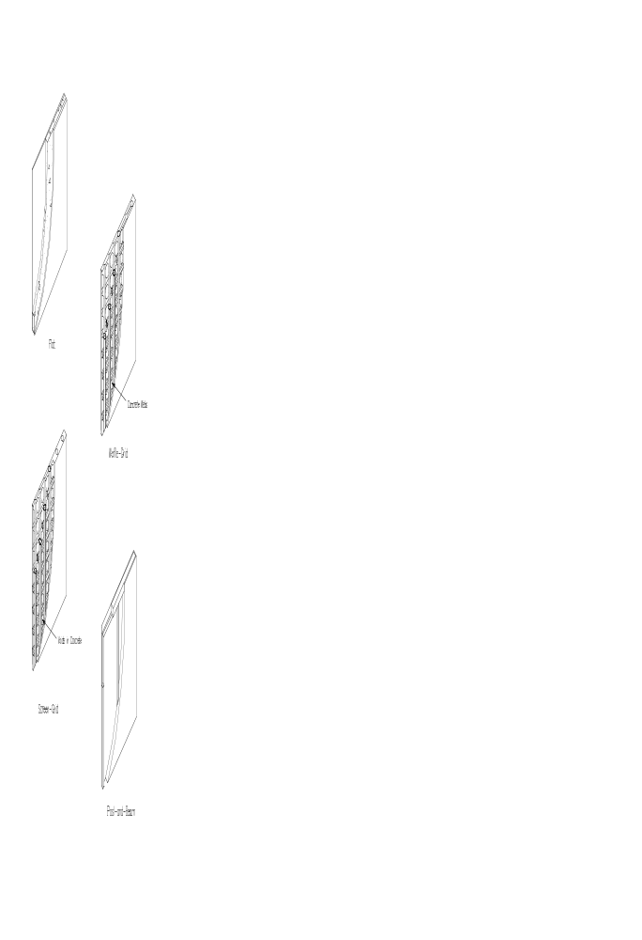

Figure 1 - ICF Wall System Types

DESCRIPTION OF HOMES

Three homes with the same floor plan were built next to each other specifically for this project. All are single-story homes on a slab-on-grade foundation. A floor plan of 1098 square foot (sf) was used in the homes as shown in Figure 2.
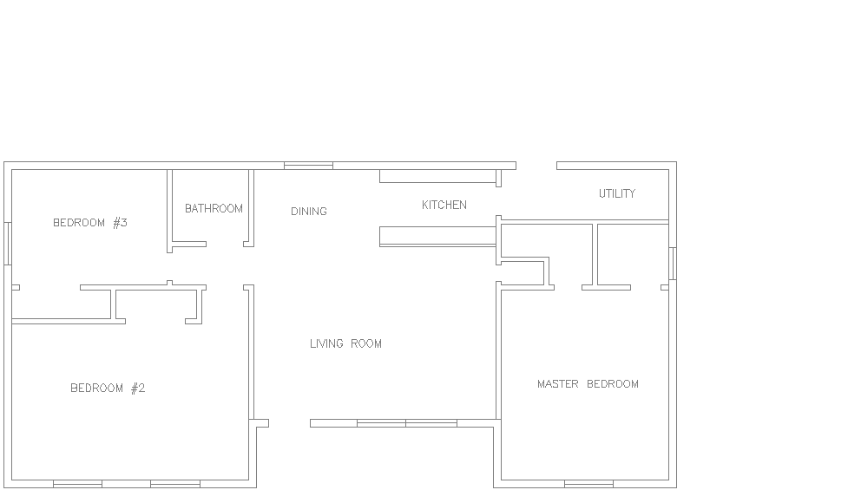

Figure 2 - Floor Plan of Test Homes

One home has wood-frame walls and was used as the baseline for comparison to the ICF homes. It represents the prevalent type of above-grade wall construction in this part of the United States. The other two homes have ICF walls, one with a block system called "Reddi-Form" and the other a plank system called "Lite-Form." The ICF systems are used for the above-grade exterior walls and the foundation walls. The wood-framed home is constructed with 2x4 wall stud framing, sheathed with oriented strand-board (OSB), covered in house wrap and insulated with R-13 fiberglass batt insulation in the wall cavities. It has a conventional concrete masonry unit (CMU) foundation. All three homes have separate concrete strip footings under the foundation walls.
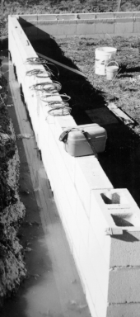
Figure 5 - CMU stemwall

Figure 5 – CMU Foundation Wall
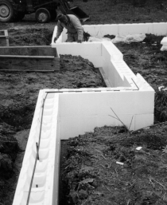Figure 3 - Reddi-Form System

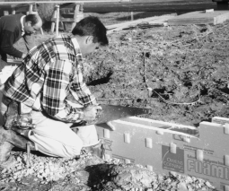
Figure 4 - Lite-Form System

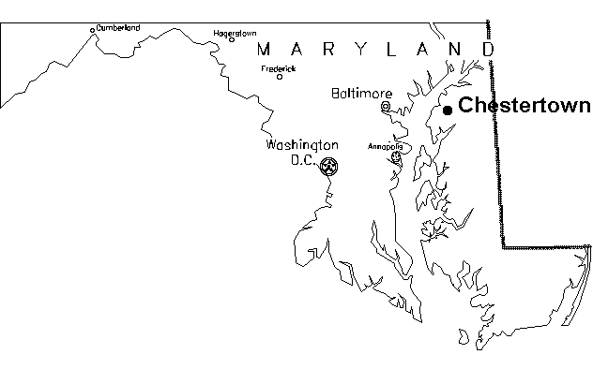
Figure 6- Location Map

Chesapeake Bay

The homes are located in Chestertown, Maryland, a rural county on the Eastern Shore of Maryland. The Eastern Shore is the part of Maryland separated from the rest of the state by the Chesapeake Bay. Figures 7 and 8 show the location of the site and the site plat. The Reddi-Form house is on Lot 61, the wood frame house on Lot 62, and the Lite-Form house on Lot 63.
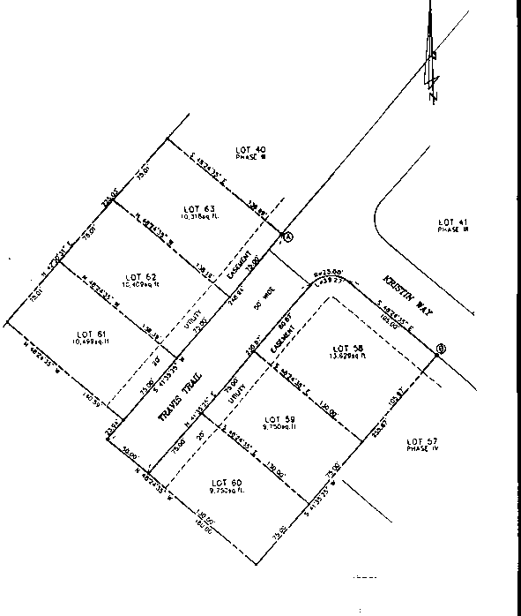

Figure 7 -Site Plat

The wood-frame house model had been constructed multiple times by the same builder in the past. Likewise, the builder had used Reddi-Form on this same model many times before. This was the builder’s first experience with Lite-Form.

APPROACH

NAHB Research Center staff assisted in the design and monitored the construction of the homes. During this period, we recorded labor requirements, material quantities, and material costs. We also instrumented the homes to facilitate later energy monitoring. The homes are being leased from the builder for a 12-month period to allow for post-construction sound and energy testing. Details on the approach for data gathering are contained in the following sections.

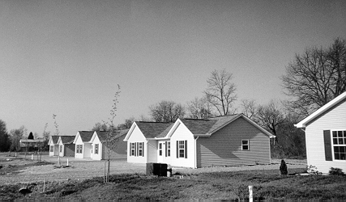

Figure 8 - View of Completed Homes

Installed Time
Time required to complete site activities was recorded by Research Center staff over 15-minute intervals. The 15-minute interval could easily accommodate 5-minute, 2-1/2-minute, or one-minute sub-intervals when further detail was necessary. For example, the gypsum wallboard installer worked within a particular room and switched between the ceiling, interior walls and exterior walls within many of the recording intervals. This installation method required detailed information in shorter intervals to separate the costs related to exterior walls from the total costs.

Labor Costs
All of the trades involved on this project are independent labor contractors and are paid by either a lump-sum price or by piecework. This practice is common in this area and made it difficult to obtain reliable local labor wage rates. Because of the complexities involved with labor rates, such as local variances and piece-work pricing, we applied standardized hourly labor rates to the hours spent by each crew member. Hourly rates were obtained from Means 1997 Residential Cost Data. Assumptions on the crew’s labor rates are documented in Appendix A.

Materials
Information was obtained by project staff on the cost of materials of all three foundation and above-grade wall systems. The Reddi-Form ICF price is the actual price the manufacturer charges the builder. The Lite-Form ICF price includes a 10 percent contractor volume discount applied to the manufacturer’s typical contractor prices. The Lite-Form information was obtained from corporate personnel and does not reflect any price changes by local distributors.

Other material costs were obtained from the invoices of the wholesale suppliers. All purchases were made by the builder for a specific lot, which helped in allocating the costs. Throughout the monitoring process all materials were counted and measured by Research Center staff as they were used. Scrap, waste and temporary use materials were included.

Sound Tests
Field sound transmission loss measurements were conducted on the homes using ASTM E966-92 “Standard Guide for Field Measurement of Airborne Sound Insulation of Building Facades and Facade Elements,” and ASTM E1332-90 “Standard Classification for Determination of Outdoor-Indoor Transmission Class.”

Sound tests were conducted on the left side of the homes using the front and rear bedrooms. The front bedroom had two windows facing the front yard and none on the left side. The rear bedroom had one window facing the side yard and none on the back wall. A sound source was deployed both inside and outside of the home. The rooms were evaluated for sound transmission both from inside-to-outside and outside-to-inside to calculate an average transmission loss for each wall assembly. A fixed loudspeaker was directed at the walls with a 45 degree angle of incidence. The speaker produced a sound range from 50 to 10,000 Hertz. Sound pressure levels were measured flush to the inside and outside surfaces of the wall using a 1/3 octave band sound analyzer.

Energy and Thermal Tests
Thermal and diagnostic tests are underway to measure and evaluate the actual energy use of the homes. Measured data will include indoor and outdoor temperatures, air infiltration rates, and heat pump energy consumption. The measured energy use data will be compared to simulations from the Building Loads Analysis and System Thermodynamics (BLAST) Program. Thermal comfort data will also be measured and evaluated.

FINDINGS: LABOR AND COSTS

For the purposes of this study, we have included time data and material costs only for items that are impacted by the presence of the ICFs. For example, HVAC installation and the plumbing rough-in had no discernable impact and are not included in the analysis. Likewise, we included labor time for siding installation since it is affected by the ICFs, but we only include material costs for the fasteners and/or furring needed for the siding. Material costs for the actual siding are not included, since they are identical for each home. Thus we caution against using the time data or cost data for estimating purposes. Use of the data should be limited to comparative analysis of the three framing systems.

The study was designed to assess costs for comparable parts of the wall. The ICF costs were based on an insulated structural wall. Likewise, the cost to insulate the wood framed walls is included in the cost numbers. We did not attempt to normalize the costs to the effective R-value of the walls.

Labor Hours and Costs
Table A lists the total productive labor hours for each part of the homes that would be affected if a builder decided to use ICFs instead of wood framing. Table A includes only the productive time; other time such as idle periods are backed out of these numbers. Details on the labor data are contained in Appendix A.
Table A
Total Productive Labor Hours by House Type and Component
COMPONENT | HOUSE TYPE
 | Reddi-Form | Lite-Form | Wood
Foundation Wall | 9.96 | 15.82 | 18.53
Above-Grade Wall | 58.32 | 81.09 | 42.17
Total | 68.28 | 96.91 | 60.70

Table B shows the results of applying standardized labor rates to the labor times recorded for each home. Assumptions for the labor rates are documented in Appendix A.

Table B
Labor Cost by House Type and Component
COMPONENT | HOUSE TYPE | Total Cost | Cost/sf wall area | Cost/sf floor area
Foundation Wall | Reddi-Form | $308.27 | $1.03 | $0.28
 | Lite-Form | $489.62 | $1.64² | $0.45
 | Wood | $554.98 | $1.40 | $0.51
Above-Grade Wall | Reddi-Form | $1,661.78 | $1.40 | $1.51
 | Lite-Form | $2,348.72 | $1.97⁴ | $2.14
 | Wood | $1,175.93 | $0.99⁴ | $1.07
Total | Reddi-Form | $1,970.05 | $1.32 | $1.80
 | Lite-Form | $2,838.34 | $1.91⁵ | $2.59
 | Wood | $1,730.91 | $1.09⁵ | $1.58

Material Costs
Table C contains the materials costs for each home. Details are provided in Appendix B. Note that the material costs for the ICF homes are over 100 percent higher than the material costs for the wood-framed home. The most significant costs are related to the forms themselves followed by the concrete.

Table C
Material Costs by House Type and Component
COMPONENT | HOUSE TYPE | Total Cost | Cost/sf wall area | Cost/sf floor area
Foundation Wall | Reddi-Form | $1,009.72 | $3.39 | $0.92
 | Lite-Form | $1,055.65 | $3.54 | $0.96
 | Wood | $779.87 | $1.96 | $0.71
Above-Grade Wall | Reddi-Form | $3,572.75 | $3.00 | $3.25
 | Lite-Form | $3,148.73 | $2.64 | $2.87
 | Wood | $1,249.74 | $1.05 | $1.14
Total | Reddi-Form | $4,582.47 | $3.08 | $4.17
 | Lite-Form | $4,204.38 | $2.82 | $3.83
 | Wood | $2,029.61 | $1.28 | $1.85
Notes: Methods and assumptions for sf calculations are the same as described in the footnotes to Table B.

Total Labor and Material Costs
Table D summarizes the total costs to install the foundation wall and above-grade exterior walls for each house type. The data show that the foundation wall costs of the ICFs can be competitive with the more-conventional CMU wall used on the wood-framed home. The Lite-Form foundation was slightly (15 percent) higher than the CMU foundation. Some of the Lite-Form costs were undoubtedly attributable to the inexperience of the builder with this specific ICF system.

Table D
Total Labor and Material Cost by House Type and Component
COMPONENT | HOUSE TYPE | Total Cost | Cost/sf wall area | Cost/sf floor area
Foundation Wall | Reddi-Form | $1,317.99 | $4.42 | $1.20
 | Lite-Form | $1,545.27 | $5.19 | $1.41
 | Wood | $1,334.85 | $3.36 | $1.22
Above-Grade Wall | Reddi-Form | $5,234.53 | $4.40 | $4.77
 | Lite-Form | $5,497.45 | $4.62 | $5.01
 | Wood | $2,425.67 | $2.04 | $2.21
Total | Reddi-Form | $6,552.52 | $4.40 | $5.97
 | Lite-Form | $7,042.72 | $4.73 | $6.41
 | Wood | $3,760.52 | $2.37 | $3.42
Notes: Methods and assumptions for sf calculations are the same as described in the footnotes to Table B.

The total installed costs of the ICF systems were $2792 and $3282 greater than the wood-framed home. This is about 3 to 3 ½ % of the $94,000 sale price reported by the builder. The above-grade wall costs represented the bulk of this difference. Again, the material costs for the ICFs are the biggest factors.

Labor and Cost Observations
Reddi-Form was the most efficient method of construction in terms of overall labor time for the combined foundation and above-grade wall system. The Lite-Form construction took 44 percent longer than the comparable Reddi-Form home for these same components. For the above grade walls, the wood-frame home took the least time to construct, approximately one-third quicker than the above-grade Reddi-Form walls. The framers were experienced carpenters and clearly enjoyed working with wood. Although the impact of this greater experience with wood would be hard to quantify, we do not believe it would have a significant impact on the labor hours based on our experience in assessing labor requirements on other wood-frame buildings.
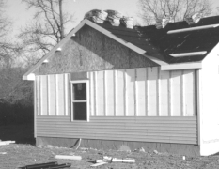Figure 9 - Vinyl Siding on Reddi-Form House

The installers were also very familiar with the Reddi-Form system, knew what work needed to be done, and had a clear idea of the division of labor required to optimize the construction time. Conversely, this was their first experience with Lite-Form. Previous observations of ICF construction suggest that it may take a minimum of three homes for a crew to get over the learning curve.

The Lite-Form siding also took significantly longer to install than on the other homes because an aluminum screwing surface was used on three of the walls. This is not the recommended practice for Lite-Form, but rather it resulted from inexperience on the part of the siding contractor in working with the attachment surfaces built into the Lite-Form product. We did not include the costs associated with the screwing surface in our comparisons, since this practice would not normally be required with Lite-Form.

Several general observations related to construction labor time include:

- both ICF foundation walls took less time to complete than the concrete block foundation wall used in the wood-frame house;
- the wood-frame above-grade walls were the quickest to erect; and
- the overall time to complete the Reddi-Form foundation and above-grade walls was comparable to the wood frame house.

The material costs for both ICF systems were more than double the costs associated with the conventional CMU foundation and wood-frame walls. Most of the cost difference is for the ICF components and the concrete. Significant reductions in the cost of ICFs are possible and would likely be achieved by reducing the cost of the ICF materials, and reducing the quantity of concrete.
Reducing the amount of concrete required for ICFs also has the potential to decrease the labor hours and material costs. For example, thinner walls will reduce the load the forms need to support, possibly permitting the use of lower-density foams, increased spacing of ties, or increased course height.

Small reductions in the labor time and material cost are also possible. For example, the labor to set the forms was a large factor in the extra time required to build the ICF walls compared to the wood walls. Several areas to further investigate as a way to speed up production include:

- increasing the height of each ICF course;
- producing ICF block heights that correspond to horizontal rebar spacing;
- reducing or eliminating rebar requirements;
- optimizing opening locations and sizes to reduce cutting of blocks;
- using half height blocks to eliminate horizontal block cutting; and
- cutting openings after the wall is erected.

FINDINGS: SOUND TESTS

The field sound transmission classification (FSTC) values for each home are presented in Table E, based on the field measurements of transmission for blank wall loss as shown in Figure 10. A larger FSTC number indicates less sound being transmitted through the walls, i.e., a quieter home. Detailed information from the sound contractor’s report is presented in Appendix C. The acoustic tests demonstrate that the blank walls (no windows) constructed with Lite-Form and Reddi-Form had superior low frequency noise reduction properties and corresponding higher ratings than conventional stud construction. When windows were located within the ICF wall, however, the sound performance of the wall assembly was closely tied to the greater sound transmission through the window (see Figure 11).

Table E
FSTC Ratings
Wall Assembly | FSTC
Lite-Form | 42
Stud | 34
Reddi-Form | 40

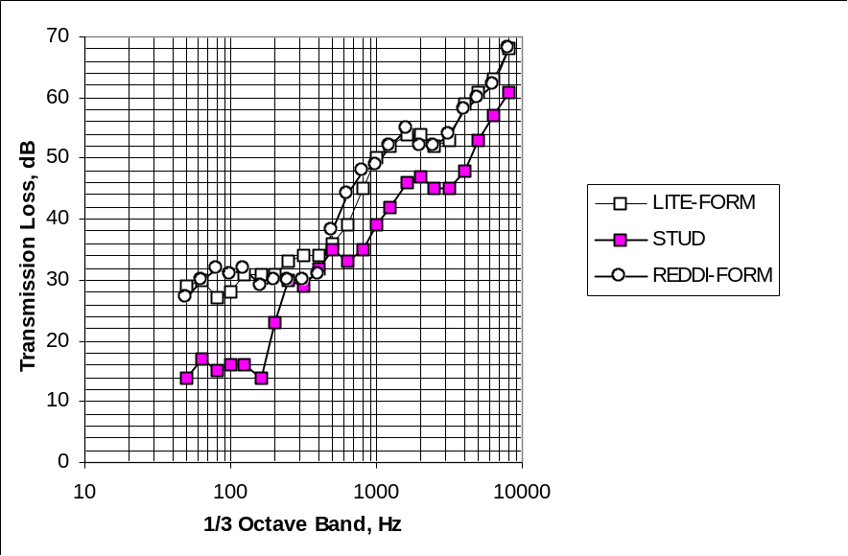

Figure 10 - Comparisons of Average Transmission Loss

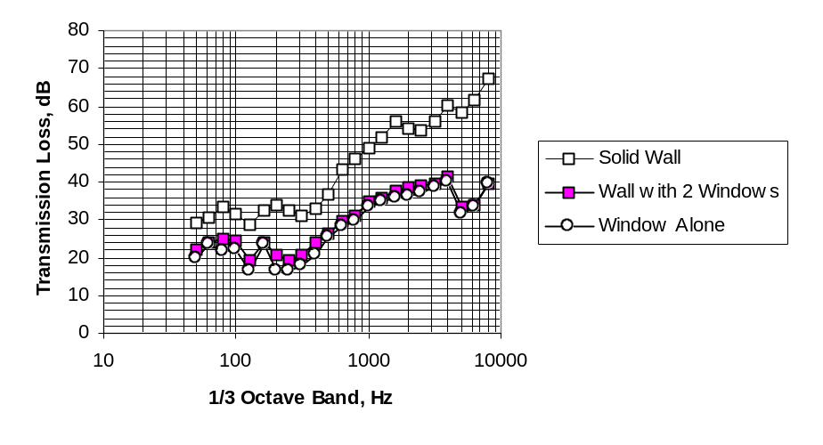

Figure 11 - Reddi-Form Wall with Multiple Windows

There is no direct way to relate field STC ratings for the three wall assemblies shown in Table E to a comfort level for occupants. One indirect measure of STC that is frequently used for comparative purposes is contained in the major U.S. model building codes. An STC of 45 under laboratory conditions is the minimum typically required for wall assemblies between attached townhomes. According to our sound consultant, field STCs can be as much as five points lower than the same assembly tested in a laboratory. In a laboratory setting, it is likely that the ICF homes without openings would meet the minimum STC for attached homes specified in most codes.

ENERGY AND THERMAL PERFORMANCE

Construction of the homes is now complete and all instrumentation is in place. Initial energy consumption is being monitored and will continue over the next year.

Measurements will be taken to determine the actual energy use of the two ICF houses and the wood-frame house. Heat pump electric consumption will be measured using a watt transducer placed at the utility breaker panel. The data will also be used to conduct comparative modeling using BLAST (Building Loads Analysis and System Thermodynamics Program) in various climates throughout the United States.

Thermal comfort measurements and diagnostic tests will be completed to evaluate the performance of the ICF and wood frame wall systems. ASHRAE Standard 55 will be used to assess thermal comfort. We expect to conclude energy and thermal comfort monitoring and produce a final report in the spring of 1999.

CONCLUSIONS AND RECOMMENDATIONS

The following conclusions are supported by our findings.

- The use of Reddi-Form and Lite-Form increased the total home construction costs over the wood home by $2792 and $3282 respectively. This is roughly 6 to 7 percent of the home’s overall construction cost or 3 to 3.5% of the builder’s sales price. Since the crews were experienced with Reddi-Form ICF and wood framing, these two homes offer the best direct comparison. On a cost per floor area basis, the Reddi-Form was about $2.55 per square foot higher than the costs the builder incurred for the wood home.

- An overwhelming portion of the cost differences is due to the higher material costs of the ICF systems, which averaged over $2300 more than materials for the wood frame system. There are some opportunities to reduce labor costs but the amount of concrete and the ICF material costs must be reduced if ICFs are to compete in most U.S. markets with wood framing on a first-cost basis.

- The energy monitoring work that is continuing under this program will provide the data needed to assess energy-conservation benefits and its impact on paybacks, life cycle costs, and other long-term issues.

- Sound test results indicate that blank ICF walls will not transmit noise as easily as similar wood-frame walls. The ICF walls provided higher (better) field sound transmission coefficients than the wood walls. The performance differences between the ICF and wood walls decrease quickly as windows are added to the walls.

The following actions are recommended to increase the cost efficiency of ICFs:

- Optimize the concrete required to meet structural requirements;
- Optimize the ICF systems based on the reduced concrete requirements; including examining lower-cost foam materials, reduced reinforcing requirements, and simplified connection details.
- Continue to improve and disseminate standardized approaches such as the HUD/PCA prescriptive method to allow builders to use ICFs in the least expensive and intrusive way possible.
- Evaluate process improvements that eliminate or combine multiple steps in the construction process. For example, stemwall foundations, in which the wall is supported directly by the soil without a separate footing, appear to be feasible with ICFs. This approach could eliminate the costs of the footing and reduce the number of trades.

It is also likely that the optimal location for the initial acceptance of ICFs is in a specialized market that would benefit from the inherent benefits of ICFs. For example, in high wind (coastal) areas, costs of ICFs may be closer to prevailing practices than to the more “conventional” wood frame methods used in Chestertown and throughout much of the interior of the United States. Likewise, in extreme colder climates where 2x6 wood walls with upgraded insulation packages are more common, ICFs may also be more competitive. Additional cost studies may be beneficial in other areas to better compare ICFs to prevailing regional construction practices.

dfgjk
APPENDIX A - DETAILED LABOR DATA

APPENDIX A - DETAILED LABOR DATA

Table 1A
Crew and Labor Details for Foundation: Reddi-Form
Activity | Crew | Hourly Rate | Productive Hours | Cost
Set ICFs | One Lead Carpenter | $31.95 | 1.63 | $ 52.08
 | One Assistant Carpenter | $29.95 | 1.63 | $ 48.82
Set Rebar | One Lead Carpenter | $31.95 | 1.09 | $ 34.83
 | One Assistant Carpenter | $29.95 | 1.09 | $ 32.65
Cast Concrete | One Lead Carpenter | $31.95 | .74 | $ 23.64
 | One Assistant Carpenter | $29.95 | .74 | $ 22.16
Parge Wall | One Lead Carpenter | $31.95 | 1.52 | $ 48.56
 | One Assistant Carpenter | $29.95 | 1.52 | $ 45.52
Total |  |  | 9.96 | $308.27

Table 1B
Crew and Labor Details for Foundation: Lite Form
Activity | Crew | Hourly Rate | Productive Hours | Cost
Set ICFs | One Lead Carpenter | $31.95 | 3.56 | $113.74
 | One Assistant Carpenter | $29.95 | 3.56 | $106.62
Set Ties | One Lead Carpenter | $31.95 | 1.41 | $ 45.05
 | One Assistant Carpenter | $29.95 | 1.41 | $ 42.23
Set Rebar | One Lead Carpenter | $31.95 | 1.02 | $ 32.59
 | One Assistant Carpenter | $29.95 | 1.02 | $ 30.55
Cast Concrete | One Lead Carpenter | $31.95 | .40 | $ 12.78
 | One Assistant Carpenter | $29.95 | .40 | $ 11.98
Parge Wall | One Lead Carpenter | $31.95 | 1.52 | $ 48.56
 | One Assistant Carpenter | $29.95 | 1.52 | $ 45.52
Total |  |  | 15.82 | $489.62

Table 1C
Crew and Labor Details for Foundation Wall: Wood-Frame Home
Activity | Crew | Hourly Rate | Productive Hours | Cost
CMU Wall | One Mason | $29.95 | 14.2 | $425.29
Parge Wall | One Mason | $29.95 | 3.29 | $ 98.54
Foundation Insulation | One Carpenter | $29.95 | 1.04 | $ 31.15
Total |  |  | 18.53 | $554.98
Notes: 1. Crew make-up and hourly rates are from 1997 Means Residential Cost Data.
2. Rates are not adjusted for location and reflect charges to the builder, including subcontractor’s overhead and profit.

Table 2A
Crew and Labor Details for Above-Grade Walls: Reddi-Form
Activity | Crew | Hourly Rate | Productive Hours | Cost
ICF Wall Construction | One Lead Carpenter | $31.95 | 13.19 | $ 421.42
 | One Assistant Carpenter | $29.95 | 13.19 | $ 395.00
Hang Gypsumboard | One Hanger | $29.95 | 2.34 | $ 70.08
Hang Siding | One Installer | $29.95 | 11.27 | $ 337.54
 | One Helper | $22.10 | 11.27 | $ 249.07
Electric Rough-In | One Master Electrician | $31.60 | .66 | $ 20.86
 | One Helper | $22.10 | 3.04 | $ 67.18
Cabinet Blocking/Trim | One Carpenter | $29.95 | 1.8 | $ 53.91
Doors/Windows | One Carpenter | $29.95 | 1.56 | $ 46.72
Total |  |  | 58.32 | $1,661.78

Table 2B
Crew and Labor Details for Above-Grade Walls: Lite-Form
Activity | Crew | Hourly Rate | Productive Hours | Cost
ICF Wall Construction | One Lead Carpenter | $31.95 | 22.61 | $ 722.39
 | One Assistant Carpenter | $29.95 | 22.61 | $ 677.17
Hang Gypsumboard | One Hanger | $29.95 | 3.01 | $ 90.15
Hang Siding | One Installer | $29.95 | 13.19 | $ 395.04
 | One Helper | $22.10 | 13.19 | $ 291.50
Electric Rough-In | One Master Electrician | $31.60 | .7 | $ 22.12
 | One Helper | $22.10 | 2.9 | $ 64.09
Cabinet Blocking/Trim | One Carpenter | $29.95 | .38 | $ 11.38
Doors/Windows | One Carpenter | $29.95 | 2.5 | $ 74.88
Total |  |  | 81.09 | $2,348.72

Table 2C
Crew and Labor Details for Above-Grade Walls: Wood-Frame
Activity | Crew | Hourly Rate | Productive Hours | Cost
Wall Construction | One Lead Carpenter | $31.95 | 6.51 | $ 208.00
 | One Assistant Carpenter | $29.95 | 6.51 | $ 194.97
Hang Gypsumboard | One Hanger | $29.95 | 2.51 | $ 75.17
Hang Siding | One Installer | $29.95 | 10.01 | $ 299.80
 | Helpers | $22.10 | 10.76 | $ 237.80
Electric Rough-In | One Master Electrician | $31.60 | .28 | $ 8.85
 | One Helper | $22.10 | 2.05 | $ 45.31
Insulation | Two Installers | $29.95 | 2.04 | $ 61.10
Doors/Windows | One Carpenter | $29.95 | 1.5 | $ 44.93
Total |  |  | 42.17 | $1,175.93
Notes: 1. Crew make-up and hourly rates are from 1997 Means Residential Cost Data.
2. Rates are not adjusted for location and reflect charges to the builder, including subcontractor’s overhead and profit.
3. Wood-frame wall construction includes framing and air barrier installation.

dfgjk dfgjk
APPENDIX B - DETAILED MATERIAL COST DATA

APPENDIX B - DETAILED MATERIAL COST DATA

Table B1
Material Estimates

Component | Item | Units | Reddi- Form |  |  | Lite-Form |  |  | Wood frame
 |  |  | Qty. | Unit | Total | Qty. | Unit | Total | Qty. | Unit | Total
 |  |  |  | Cost | Cost |  | Cost | Cost |  | Cost | Cost
Footing | Concrete | cubic yards | 7 | $60.20 | $421.40 | 7 | $60.20 | $421.40 | 7 | $60.20 | $421.40
 | Rebar | lineal feet | 453.23 | $0.20 | $91.29 | 453.23 | $0.20 | $91.29 | 353.77 | $0.20 | $71.26
 | Total |  |  |  | $512.69 |  |  | $512.69 |  |  | $492.66
Stem Wall | ICF Block | blocks | 72.75 | $7.85 | $571.09 | 126.05 | $2.83 | $356.31
 | Bottom ties | number |  |  |  | 223 | $0.28 | $62.44
 | Top ties | number |  |  |  | 642 | $0.28 | $179.76
 | Corner ties | number |  |  |  | 24 | $1.48 | $35.52
 | Concrete | cubic yards | 1.7 | $69.20 | $117.64 | 1.65 | $69.20 | $114.18
 | Rebar | lineal feet | 336.70 | $0.20 | $67.82 | 283.70 | $0.20 | $57.15
 | Slab ties | number | 114.9 | $0.17 | $19.53 | 114.9 | $0.17 | $19.53
 | Adhesive | 29 fl. oz. tube | 0.85 | $3.39 | $2.88
 | Lumber | lineal feet | 148.33 | $0.44 | $64.80 | 148.33 | $0.44 | $64.80
 | Nails (12d) | number | 151 | $0.01 | $1.32 | 151 | $0.01 | $1.32
 | Surface Bonding Cement | 50 lb. Bag | 7 | $8.82 | $61.74 | 7 | $8.82 | $61.74
 | Concrete Fortifier | 1 gallon | 7 | $14.70 | $102.90 | 7 | $14.70 | $102.90
 | CMU Block | number |  |  |  |  |  |  | 337 | $0.80 | $269.60
 | CMU headers | number |  |  |  |  |  |  | 103 | $1.60 | $164.80
 | Cement | 94 lb. bag |  |  |  |  |  |  | 12 | $5.25 | $63.00
 | Sand | cubic yards |  |  |  |  |  |  | 1.875 | $14.00 | $26.25
 | Anchor bolts | number |  |  |  |  |  |  | 32 | $1.00 | $32.00
 | 2" XPS Insul. | 4'x8' sheets |  |  |  |  |  |  | 143.50 | $1.56 | $224.22
 | Total |  |  |  | $1,009.72 |  |  | $1,055.65 |  |  | $779.87
Exterior Wall | ICF Block | blocks | 245.85 | $7.85 | $1,929.92 | 366.80 | $2.83 | $1,036.83
 | Bottom ties | number |  |  |  | 111 | $0.28 | $31.08
 | Top ties | number |  |  |  | 1703 | $0.28 | $476.84
 | Corner ties | number |  |  |  | 88 | $1.48 | $130.24
 | Top corner ties | number |  |  |  | 16 | $0.42 | $6.72
 | Concrete | cubic yards | 14.3 | $69.20 | $989.56 | 13.85 | $69.20 | $958.42
 | Rebar | lineal feet | 1342.30 | $0.20 | $270.38 | 1066.50 | $0.20 | $214.82
 | Adhesive | 29 fl. oz. tube | 7.15 | $3.39 | $24.24
 | Top Plate (2x10) | lineal feet | 145.5 | $1.05 | $152.32
 | Top Plate (2x8) | lineal feet |  |  |  | 145.5 | $0.83 | $121.13
 | Anchor bolts | number | 48 | $0.37 | $17.76 | 48 | $0.37 | $17.76
 | Window bucks (2x8) | lineal feet |  |  |  | 172 | $0.83 | $143.19
 | Window bucks (3/4 plywood) | 4'x8' sheets | 7.85 | $22.76 | $178.67
 | 40d nails | number | 110 | $0.09 | $9.90 | 130 | $0.09 | $11.70
 | Wood framing | lump sum |  |  |  |  |  |  | N/A | N/A | $590.00
 | Sheathing | 4'x8' sheets |  |  |  |  |  |  | 37 | $6.89 | $256.36
 | Cavity Insulation | batts |  |  |  |  |  |  | 111.96 | $2.21 | $247.44
 | Sill Sealer | lineal feet |  |  |  |  |  |  | 145.5 | $0.10 | $14.11
 | Air barrier | lineal feet |  |  |  |  |  |  | 148.83 | $0.95 | $141.83
 | Total |  |  |  | $3,572.75 |  |  | $3,148.73 |  |  | $1,249.74

Table B1 (continued)

Component | Item | Units | Reddi- Form |  |  | Lite-Form |  |  | Wood frame
 |  |  | Qty. | Unit | Total | Qty. | Unit | Total | Qty. | Unit | Total
 |  |  |  | Cost | Cost |  | Cost | Cost |  | Cost | Cost
Siding | Furring (1x3) | lineal feet | 81 | $1.04 | $84.24
 | Furring (1x4) | lineal feet | 140.83 | $0.24 | $34.15
 | Furring (3/4 plywood) | 4'x8' sheets | 2.31 | $22.76 | $52.58
 | Adhesive | 29 fl. oz. tube | 9 | $3.39 | $30.51
 | Nails (12d) | number | 1258 | $0.01 | $11.01
 | Screws | number |  |  |  | 1376 | $0.01 | $12.38
 | Nails | number | 1355 | $0.01 | $8.13 |  |  |  | 1376 | $0.01 | $8.25
 | Total |  |  |  | $220.62 |  |  | $12.38 |  |  | $8.25
Interior Finish | Gypsum wallboard (std) | 4'x12' sheets | 63.73 | $7.75 | $493.91 | 63.73 | $7.75 | $493.91 | 63.73 | $7.75 | $493.91
 | Gypsum wallboard (green) | 4'x12' sheets | 10.85 | $7.85 | $85.17 | 10.85 | $7.85 | $85.17 | 10.85 | $7.85 | $85.17
 | Adhesive | 29 fl. oz. tube | 32 | $3.39 | $108.48 | 32 | $3.39 | $108.48 | 28 | $3.39 | $94.92
 | Nails | number | 316 | $0.01 | $2.21 |  |  |  | 971 | $0.00 | $2.91
 | Screws | number |  |  |  | 971 | $0.01 | $8.74
 | Total |  |  |  | $689.77 |  |  | $696.30 |  |  | $676.91
Electrical | Boxes | number | 54 | $0.50 | $27.00 | 54 | $0.50 | $27.00 | 54 | $0.50 | $27.00
 | Clamps | number | 200 | $0.01 | $2.00 | 200 | $0.01 | $2.00 | 235 | $0.01 | $2.35
 | Adhesive | 10.5 fl. oz. tube | 2 | $1.79 | $3.58 | 2 | $1.79 | $3.58
 | Total |  |  |  | $32.58 |  |  | $32.58 |  |  | $29.35
Interior | Fascia | lineal feet | 102.37 | $0.64 | $65.52
Trim | 12d nails | number | 188 | $0.01 | $1.65
 | Total |  |  |  | $67.17
Cabinet | Wood | lineal feet | 19.79 | $0.31 | $6.14 | 19.79 | $0.31 | $6.14
Blocking | Tapered Pin | number | 22 | $0.20 | $4.40 | 22 | $0.20 | $4.40
 | Total |  |  |  | $10.54 |  |  | $10.54

dfgjk
APPENDIX C – Excerpt from SOUND CONTRACTORS REPORT

Hessler Associates, Inc. of Cabin John, Maryland has been contracted by the NAHB Research Center to perform sound Transmission Loss (TL) measurements on three distinct types of building walls at their demonstration site located near Chestertown, Maryland. The site has three virtually identical residential individual houses constructed with three types of wall construction. The constructions were described to us as:

House #1—Lite-Form wall assembly
House #2—Conventional stud wall assembly
House #3—Reddi-Form wall assembly

The object of the testing was to compare the sound transmission loss properties of the three constructions.

2.0 Executive Summary

The solid wall portions in two rooms of each house were tested using applicable ASTM standards and later methods to acquire repeatable results for comparison. The measured average field sound transmission loss classification (FSTC) and field Outdoor Indoor Transmission Classification (OITC) for each construction, with a standard deviation of ± 1.8 rating points, are tabulated below:
FSTC OITC
House #1—Lite-Form wall assembly 42 36
House #2—Conventional stud wall assembly 34 25
House #3—Reddi-Form wall assembly 40 35

The tests demonstrated that the two walls constructed with insulating concrete (houses 1 & 3) had far superior low frequency noise reduction properties and corresponding higher ratings than conventional stud construction.

3.0 Test Method

There are two applicable ASTM standards for measuring the sound transmission through a wall assembly in the field as opposed to a laboratory. These are ASTM E966-92 “Standard Guide for Field Measurement Of Airborne Sound Insulation of Building Facades And Facade Elements”, and ASTM E1332-90 “Standard Classification for Determination of Outdoor-Indoor Transmission Class”.

3.1 ASTM E966 Test Method Discussion

E966 describes techniques for measuring the outdoor to indoor transmission loss in the field or in-situ as a function of frequency. This result is used to determine the convenient single number rating FSTC. FSTC is measured for direct comparison to STC as measured in a controlled laboratory.

From our experience, field results are always less than laboratory results by about 1 to 5 points and are not repeatable due to two major differences between the field and laboratory. In the laboratory, sound flanking around rather than through the sample is virtually eliminated. Also, the size of the laboratory test rooms are many times larger than those found in typical houses. This ensures that the angle of incidence on the sample is diffuse, i.e. from all angles. In fact, the test rooms at the NAHB site are less than half the recommended volume for testing. The result is that testing is not valid below 200 Hz but data below 200 Hz is necessary to compute the FSTC rating. E966 offers no alternative to this conundrum.

Sharp and Martin have proposed a test method where the sound is measured inside to outside which eliminates the room size problem to some degree. For this project, the TL has been measured both outside to inside and inside to outside for two rooms in each house. The four samples are than averaged and reported as the single TL result. The data shows excellent agreement between the directional methods and rooms in the higher frequency range but a large spread at low frequencies as expected. The averaging technique is considered a very satisfactory method for comparing results between samples for this test setup. However, if the “true” TL and STC rating for each construction is required then the only absolute method is ASTM E90 performed on a 9 by 14 foot sample in a certified NVLAP laboratory.

3.2 ASTM E 1332 Test Method Discussion

ASTM E 1332 is a method of assessing the TL results from either lab or field tests. The method simply subtracts the measured TL, as a function of frequency from 80 to 4000 Hz, from a reference spectrum. The resultant “A” weighted level reduction is called the Outdoor to Indoor Transmission Classification (OITC). The reference spectrum is that generated by a mix of environmental noise sources such as air and traffic so the OITC is a measure of how well the construction reduces environmental noise.

The average TL result discussed above was used for the determination.

4.0 Discussion of Results

Figure 1 illustrates the test setup at the NAHB site. Each front bedroom is approximately 10.9 W x 14.8 L x 8 H while the rear is 9.3 W x 11.5 L x 8 H feet. Both rooms were carpeted and contained no furnishings. The figure illustrates the two potential flanking paths. There were no obvious signs observed to indicate flanking was a problem.

Figures 2, 3 and 4 present the measured TL for each house. The single number FSTC rating is shown in the chart legend. The data spread improves as the frequency increases. This occurs because the rooms are small relative to the wavelength at frequencies below about 200 Hz. Figure 2 also plots the coincidence frequency for the major component materials, i.e. gypsum board and 4 inch thick light weight concrete. Performance should decrease or “dip” in these ranges which is evident on the plots.

Figure 5 presents the key findings of this project, a comparison of TL properties of the three wall constructions. In general, TL improves with increased weight or mass, by about 6 dB for each doubling of mass. The superior performance at low frequencies is attributable to the increased mass and stiffness of the two concrete constructions as compared to light weight drywall.

It should be noted that the TL of a wall containing a window or door will be much lower than a solid wall as tested for this project. In essence, the weaker door or window is a flanking path for the transmission of sound around the wall construction. Since the rooms contained both a solid wall and one with windows, the measured OITL for the solid wall, wall with windows and the window alone is plotted on Figure 6 for illustration.

The OITC value was calculated as described in the above section. The results indicate a larger difference or improvement for the concrete constructions due to the superior TL at low frequencies.
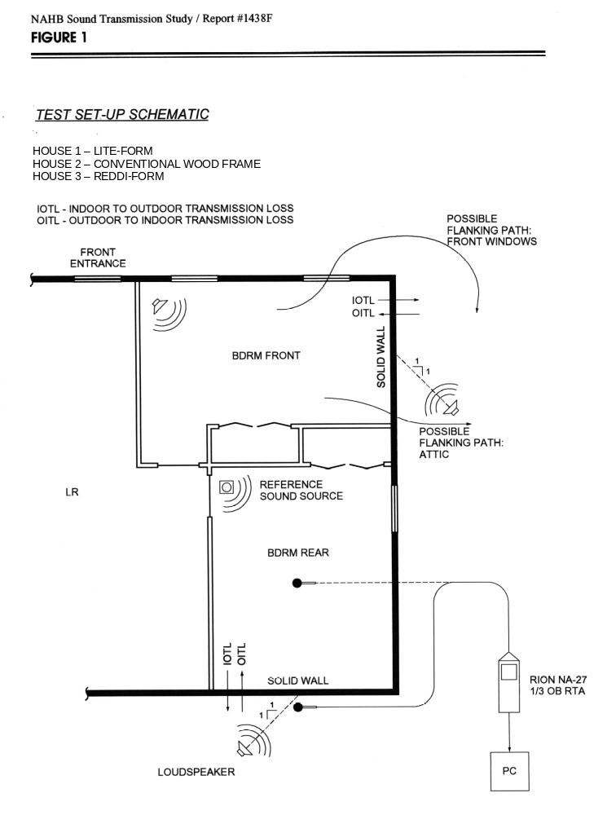
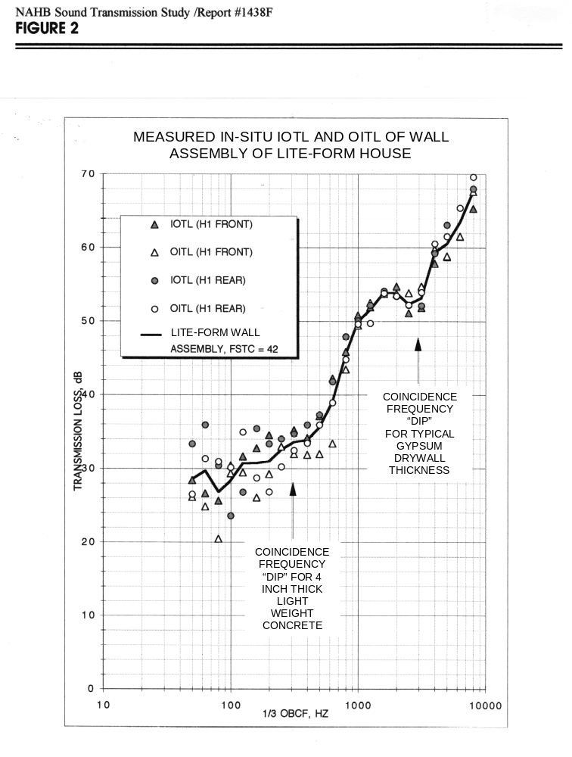
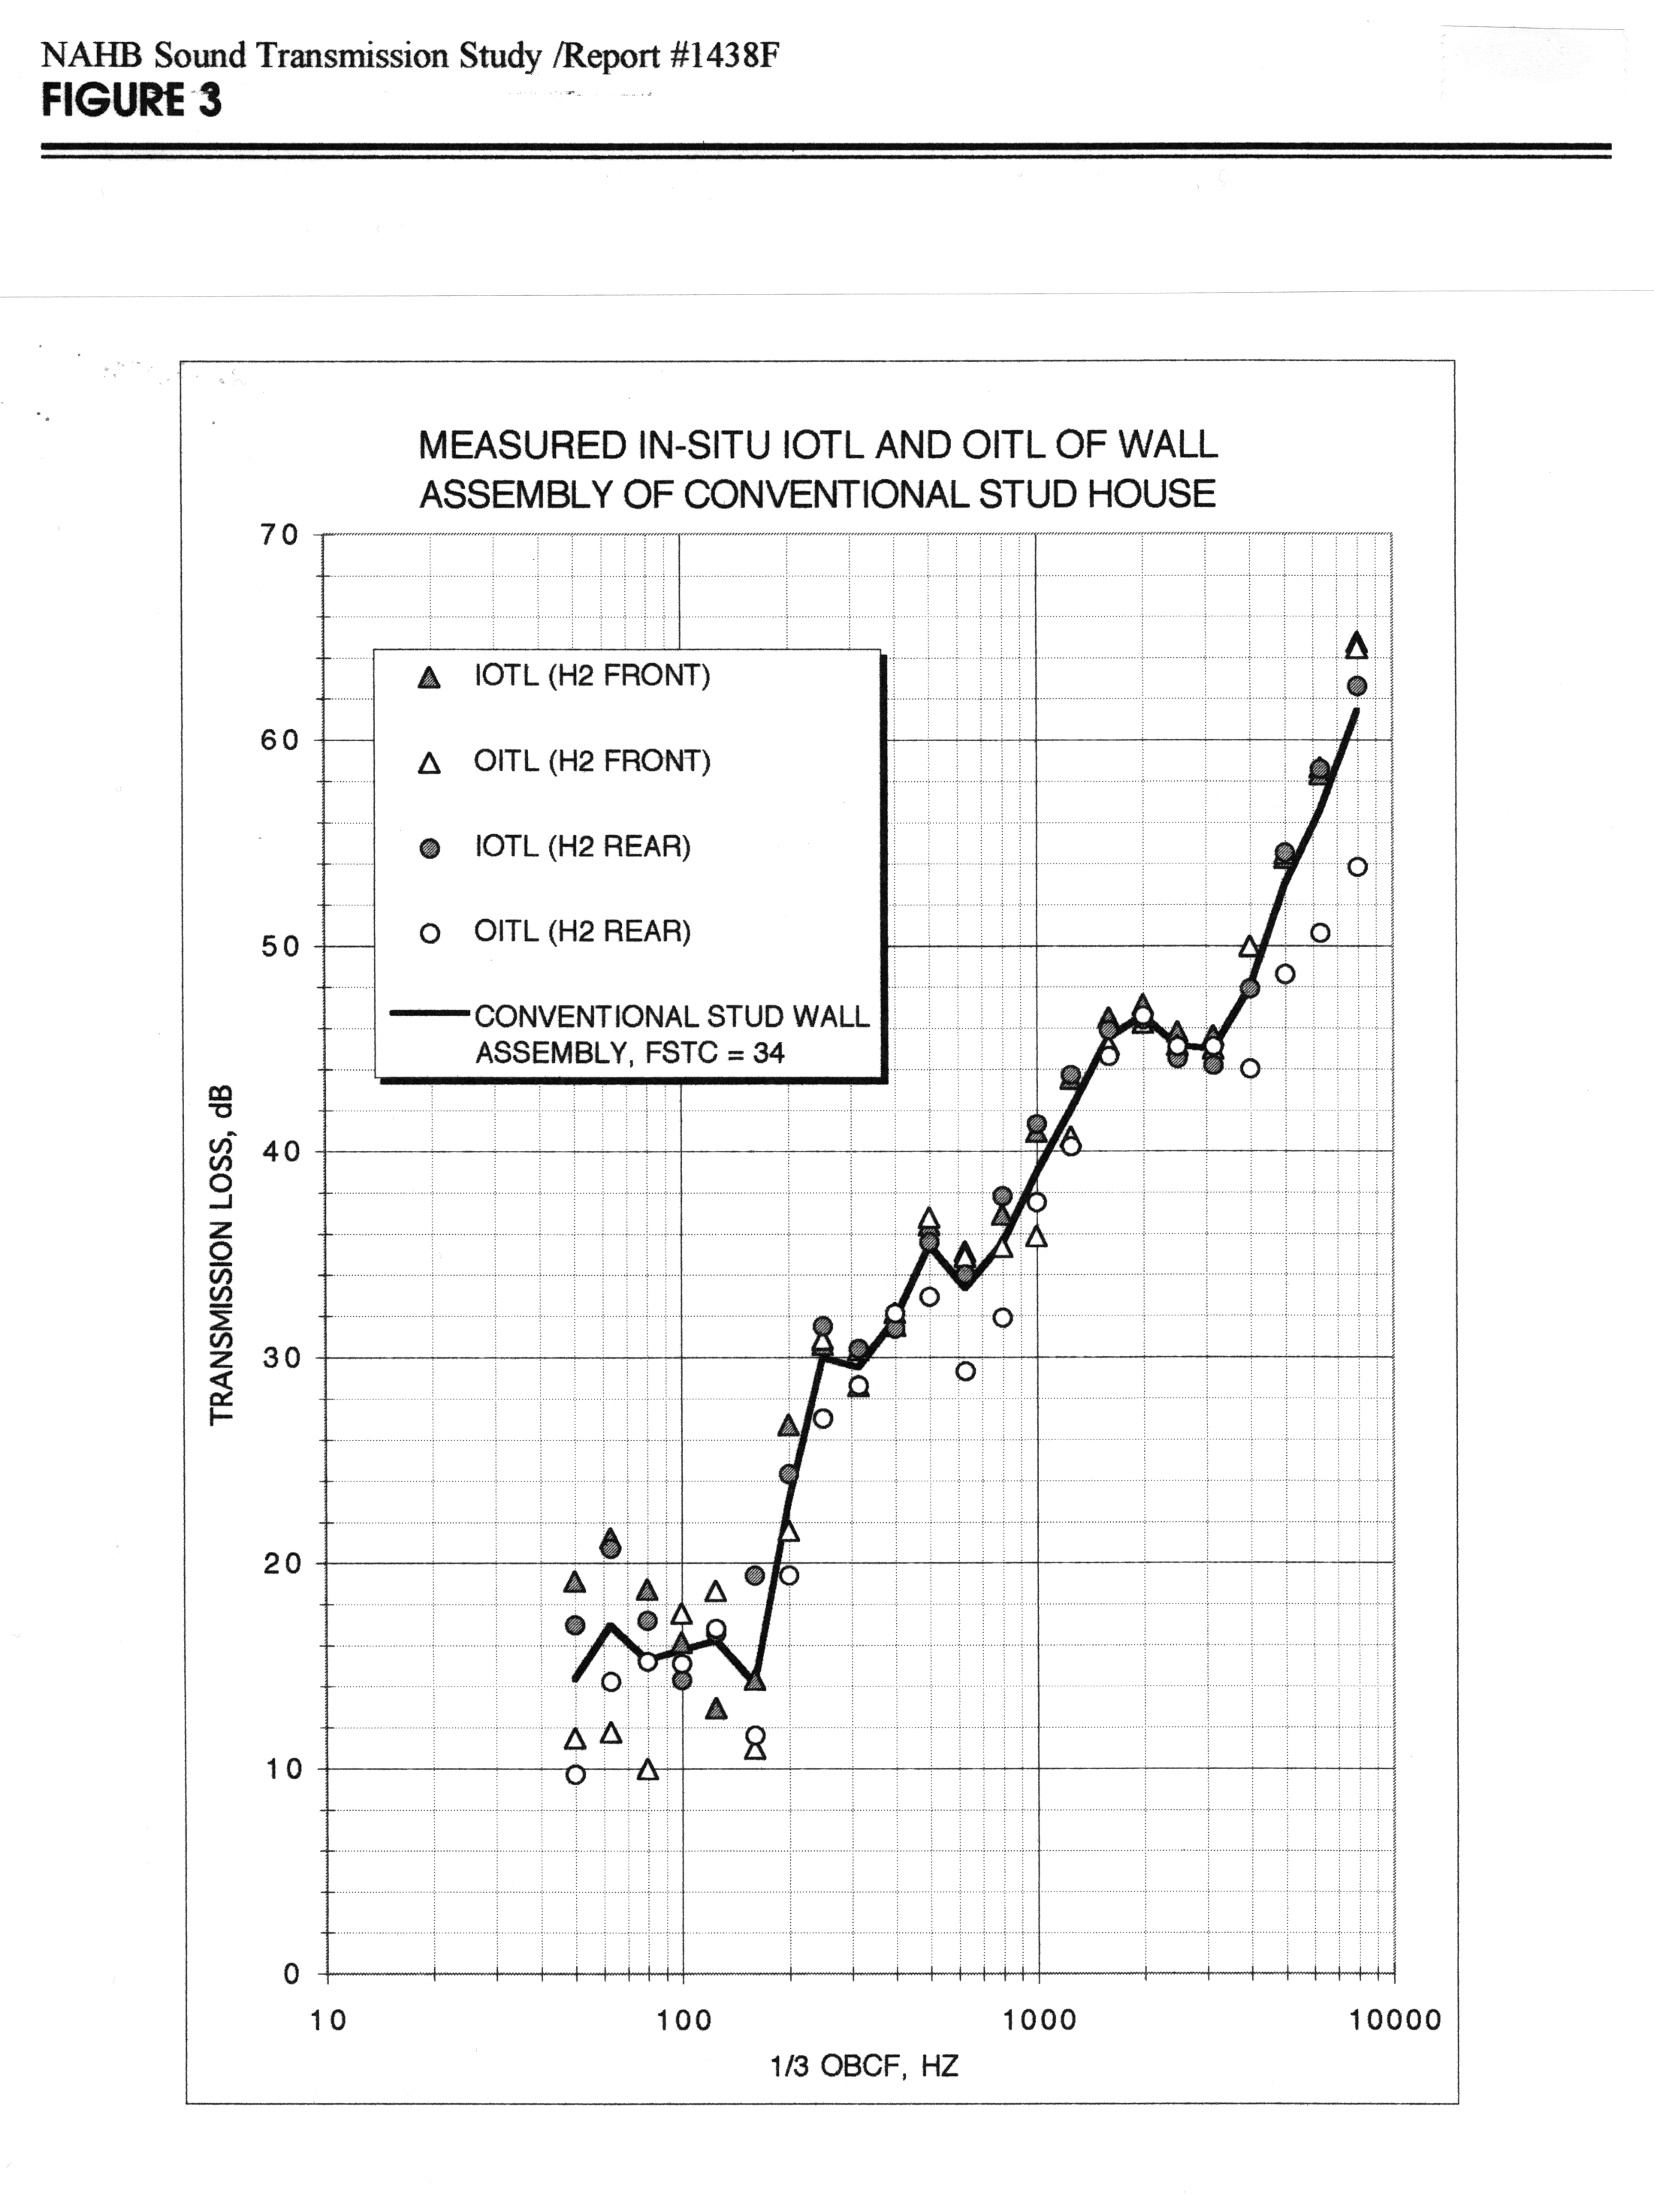
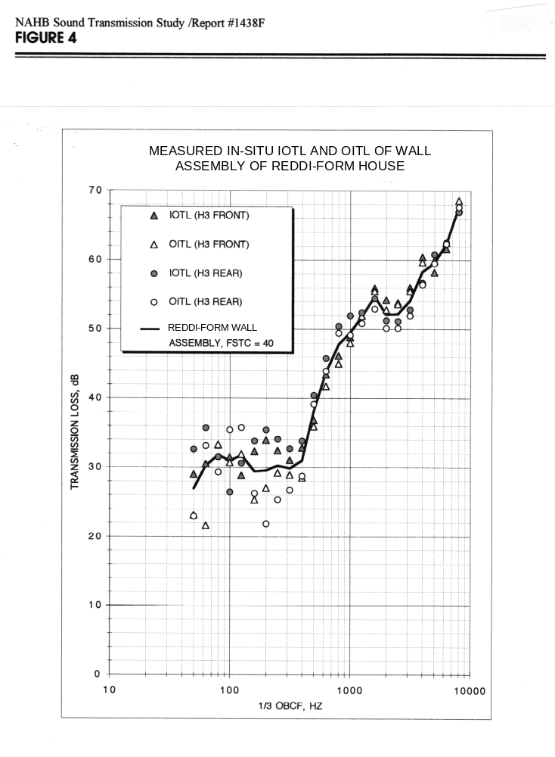
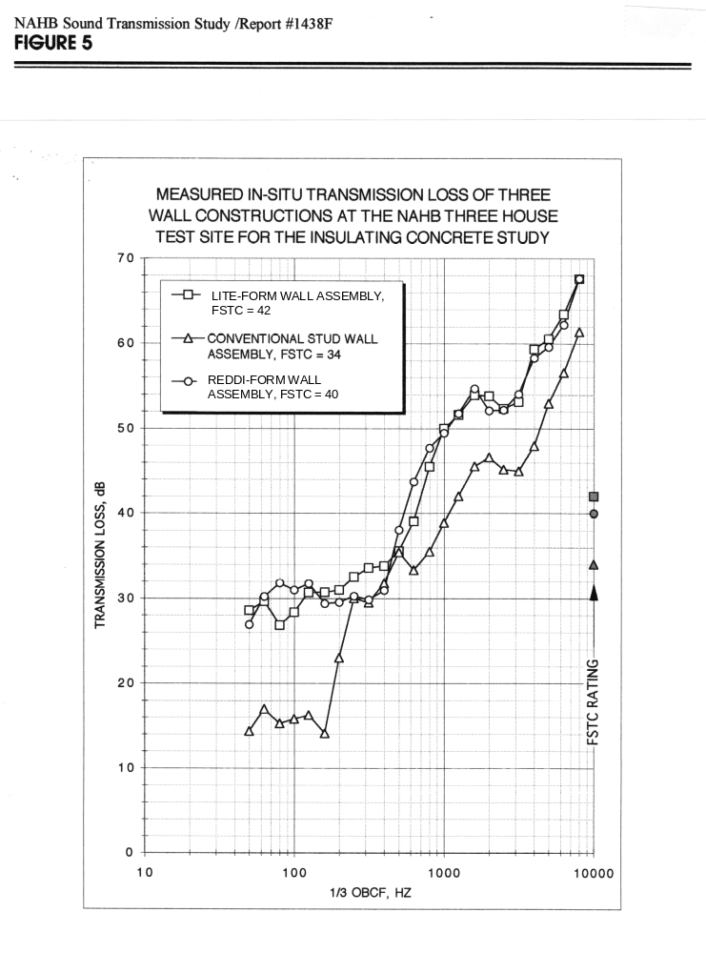
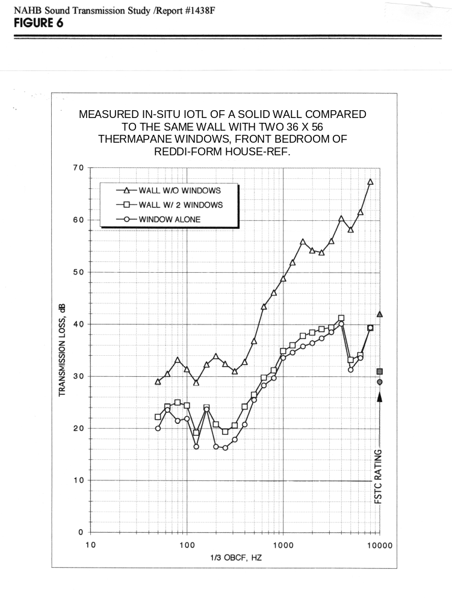

Floor area of 1098 S.F. based on exterior measurements per ANSI Standard Z765-1966, Square Footage - Method for Calculating.
Area of 298 S.F. based on foundation wall height of 2’.
Area of 397 S.F. based on foundation wall height of 2.67’.
Area of 1191 S.F. based on wall height of 8’.
Based on combined foundation and above-grade wall height.
NAHB Research Center, 1997, Insulating Concrete Forms for Residential Construction: Demonstration Homes
Sharp and Martin, The Measurement of Aircraft Noise Reduction in Residences, Proceedings of Internoise 96, Page 2747, Presented at Internoise 96, Liverpool, England.

